Added 3 icons in the right side of the dashboard

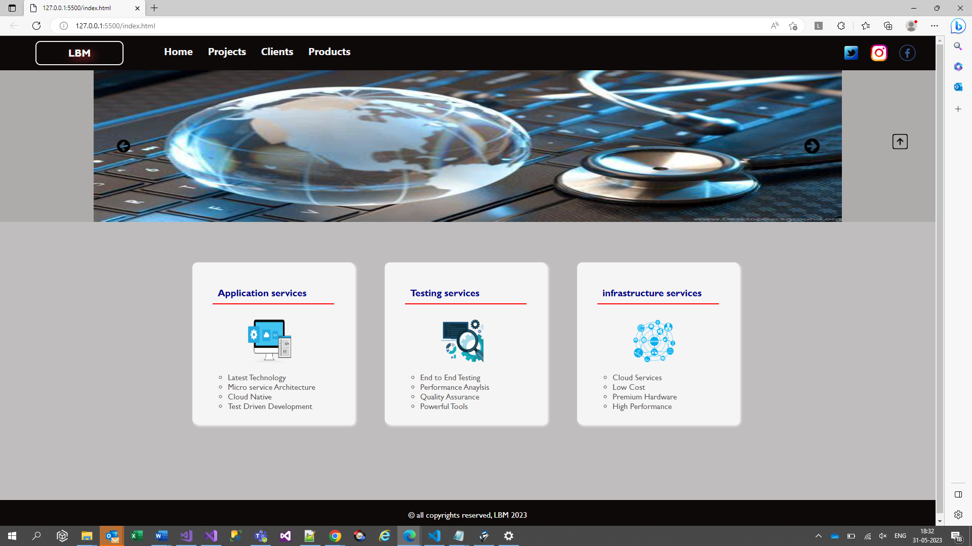

On mouse over of the icon scaling property is used

On mouse over on the image icon I’m moving the padding 50px to the right and used cursor

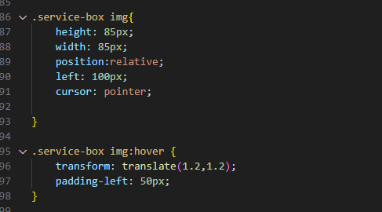

On click on the li elements a alert popup should come

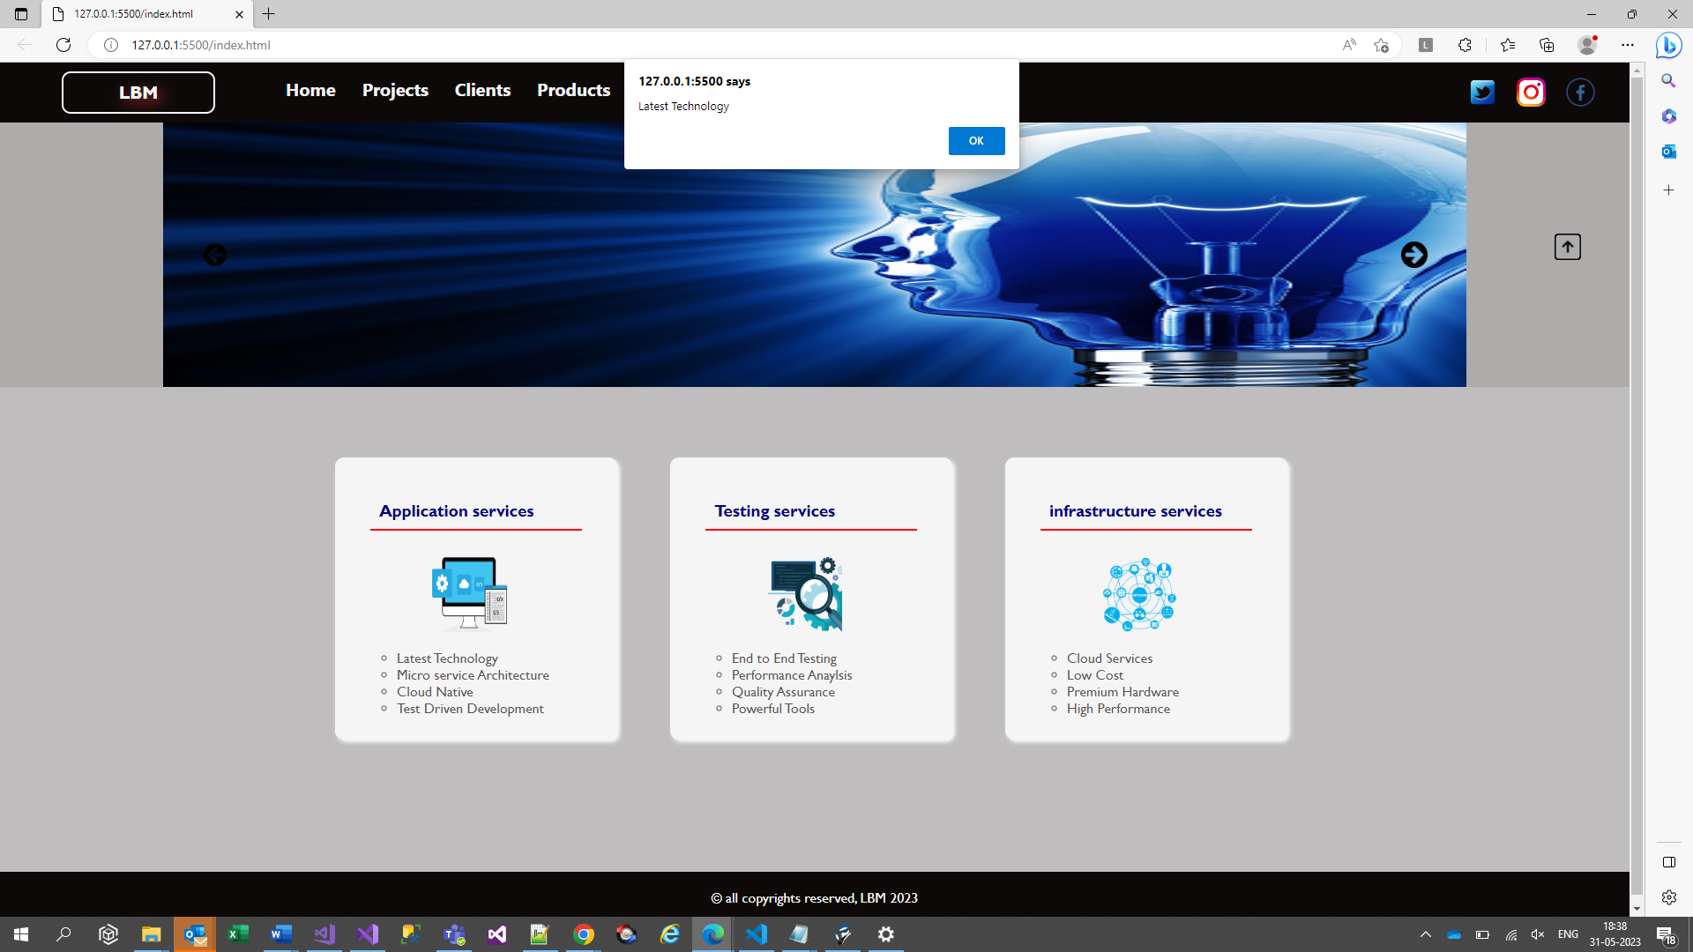

On click on the arrow key hiding the dashboard and when we click on the arrow key again I am showing the right arrow key



